Ryan Ringer

HW1 Getting started

In previous classes, a component of this class that is welcomed by a lot of students is the sense of community and having study partners. With an online class, it is hard to get to know your classmates, find study partners, and build relationship. It is harder to ask your peers questions when you do not know each other.

Students typically take CS351 around the time that the job and internship hunting process would start. Having a few classmates to interchange job hunting information, asking for references, and practice job interview coding questions together are very helpful as well.

To facilitate the process of getting to know each other, the first HW has the below tasks and you get full points by completing them.

# Upload a photo or picture to the Cougar Course & Zoom

We will heavily use the discussion forum on the cougar course for Q&A and Zoom is our main channel for discussions. Having a photo or picture will quickly help the whole class keep track of each other. When your internet is not stable and you need to join the discussion without video, your photo can show up to help others quickly know who is talking. We rely on facial expressions and body gestures to communicate effectively. It is difficult to communicate via video chat already and when the videos have to be turned off, having a photo showing up would at least help a bit.

Please find 1 photo of yourself. **If you are not willing to use your own photo, you can choose another picture that is meaningful to you, like your favorite pet.** Please upload the **same** photo or picture to both the Zoom profile and Cougar Course profile.

Here is how to change Zoom profile picture: <https://www.guidingtech.com/show-profile-picture-instead-video-zoom-meeting/>

For cougar course, you can log in and find your profile right above your class lists.



Please complete this task **as soon as possible at least by the end of week 1**. In the first 2 weeks, you can randomly join different group discussions to help you get to know a few people and find study partners. Your photo or pictures in Zoom and Cougar Course will help others remember you.

# Introduce yourself

Please go to Cougar course for this class, click on “Discussion Forums and Sign Ups” page, under the page you will find below activity:

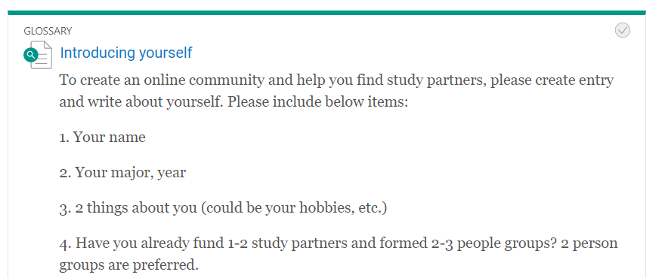

Please create an entry and introduce yourself to the class **by the end of week 1**. Also, please read about other people’s entries, together with the zoom group discussion time, get to know each other. Please find yourself 1-2 study partners **before HW1 due time (near end of week 2)**.

Once you found your study partner(s), please return to the glossary and update it to let others know that you already found study partner(s). Please kindly keep all the other info you provided so your classmates and quickly go to this page and look at your info throughout the semester.

# Find study partners

In the first two weeks, you can randomly join any discussion groups each time to get to know more people. You can also read other students’ “introduce yourself glossary”.

Please find yourself 1-2 study partners **before HW1 due time (near end of week 2)**.

Note that 2 people study groups are preferred. You will sign up for 2-4 person presentations together and complete some group assignments together.

In group assignments, only 1 person in 1 group would submit. This person needs to write down the names of your group members in the submission comment section.

You **CAN CHANGE GROUP MEMBERS** throughout this semester without notifying me. You can work with 1 person on HW1 but with another person on HW2. You only need to make sure when you are submitting the group assignments, write down the names of the people that completed this HW together.

You **CAN ALSO WORK ALONE**. Having someone to bunce ideas would be very beneficial to your study. But if you really want to, you can submit group assignments by yourself as well. The grading would be the same. You would need to complete the whole assignment by yourself in this case and might have higher workload.

# Sign up for group presentations

Another component of this course that a lot of students liked is the group presentation. Students found that they can learn a lot form each other’s presentation in a low-stress manner. Some groups make excellent presentations as well. All the presentation material would be shared to the whole class.

Please pick a topic you like and sign up for a group presentation **before HW1 due time (near end of week 2)**.

Some topics need 2 people. A study group of 2 can directly sign up. Some topics need 4 people. You can first sign up and wait for others to fill in or directly find 4 people to sign up together. Each person only needs to present once.

The presentation topics are sequential and go with the course content and serve as additional learning material. The exact time might change slightly depending on our course schedule. Please keep an eye out for notices via CC.

# How to submit:

Please submit 1 Word of Pdf file containing below screenshots.

(How to screenshot in Windows? You can use snipping tool that comes with Windows. You can also google key combinations to get screenshots in either Windows or Mac.)

Screenshot showing you have photo/picture for Zoom

Screenshot showing you have photo/picture for Cougar Course

Screenshot showing your glossary entry for introducing yourself to the class.

Your study partner(s)’s name (you can change study partner(s) later) or you are decided to complete all group assignments alone.

Reinhold Kulick

Michael Fang

Screenshot of the presentation topic that you signed up.

Grading:

5pt total. Each of the above item is 1 pt.